East Knox 25/26 First Grade Supply List
Backpack (no wheels please) | 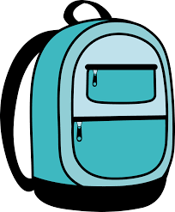 | 1 pair of Blunt-Tip Scissors | 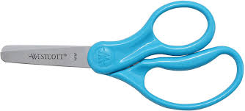
4 Glue Sticks | 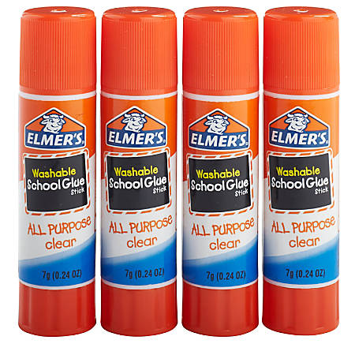 | 1” binder plain color with front pocket | 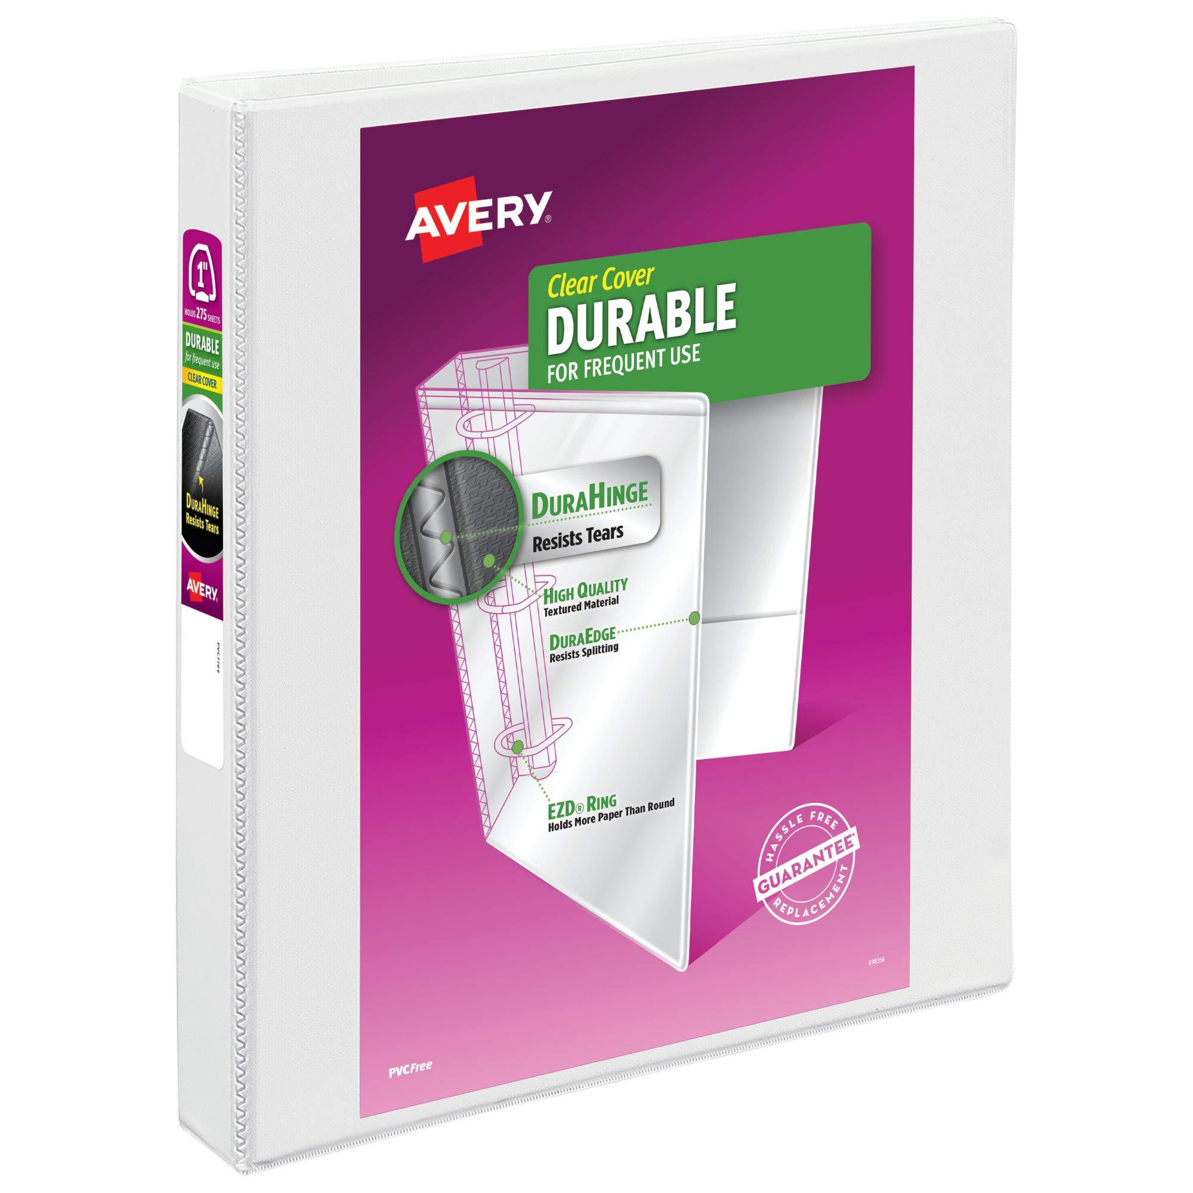
1 pair of Volume Safe Headphones with a microphone in a labeled bag  (No earbuds, not wireless or bluetooth) | 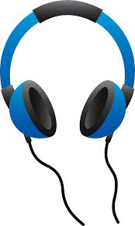 | 1 plastic pencil box | 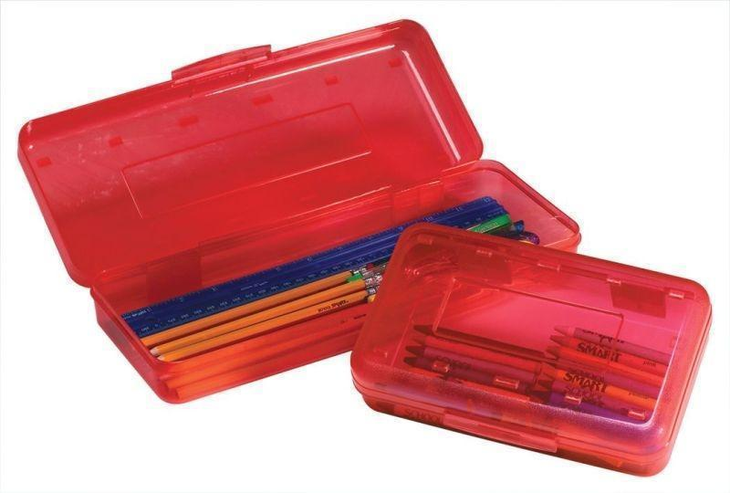
2 Boxes of Tissues | 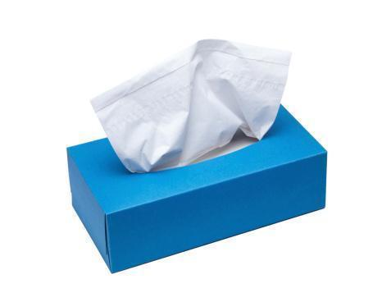 | 2 packs of Plain No.2 Pencils-  Sharpened if  possible | 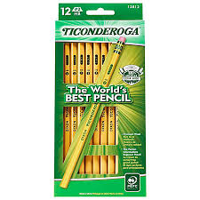
2 boxes of 24-count crayons | 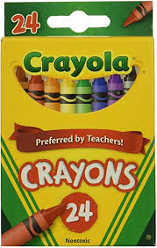 | 4 Black Dry Erase Markers | 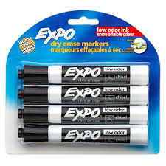
4 pack of big erasers | 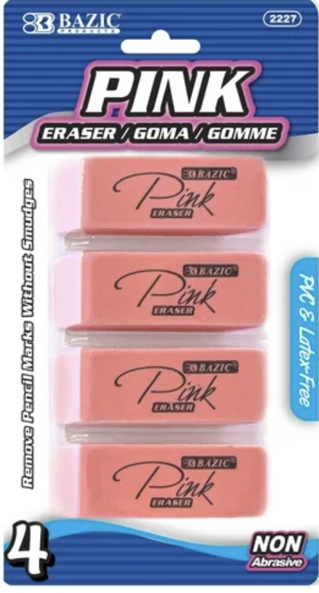
Wish List:
Each teacher will have their own wish list.

